4-8 Sedgemere Road.
Bexley, London.
Abbey Road Sedgemere Limited.

SUSTAINABILITY
CIRCULAR ECONOMY STATEMENT

REVISION P06 – 08 April 2025

Audit sheet.
Rev. | Date | Description of change / purpose of issue | Prepared | Reviewed | Authorised
P01 | 13/06/2024 | Draft issue for reference only. | S. Hunt | J. Robb | J. Nuttall
P02 | 28/06/2024 | Planning application | V. Wall | Z. Branford | T. Smith
P03 | 16/09/2024 | Updated to suit revised scheme | J. Robb | G. Papachristou | J. Nuttall
P04 | 23/09/2024 | Revised following design team comments. | J. Robb | G. Papachristou | J. Nuttall
P05 | 25/09/2024 | Revised following design team comments. | J. Robb | G. Papachristou | J. Nuttall
P06 | 08/04/2025 | Revised following GLA comments | Z. Branford | T. Smith | J. Nuttall

This document has been prepared for Abbey Road Sedgemere Limited only and solely for the purposes expressly defined herein. We owe no duty of care to any third parties in respect of its content. Therefore, unless expressly agreed by us in signed writing, we hereby exclude all liability to third parties, including liability for negligence, save only for liabilities that cannot be so excluded by operation of applicable law. The consequences of climate change and the effects of future changes in climatic conditions cannot be accurately predicted. This report has been based solely on the specific design assumptions and criteria stated herein.

Project number: 23/25289
Document reference: 2325289-HLE-XX-XX-RP-ST-602031_P06.docx

Contents.
Audit sheet. 2
Executive summary 4
Description of Proposed development. 4
Scope. 4
Circular economy strategies. 4
1. Introduction 5
1.1 Description of development 5
1.2 Policy driver 7
1.3 Method statement 9
Circular economy aspirations 10
2. Circular economy targets 11
3. Circular economy design approach 12
3.1 Existing Site 13
4. Proposed strategy for the proposed building. 15
Strategy for New Building Layers 15
4.2 End-of-life strategy 18
5. Opportunities for managing and reducing waste 19
5.1 Operational waste management plan 19
5.2 Waste during construction 19
5.3 Plans for implementation 19
6. Conclusion. 21
Appendix 22

Executive summary
This Circular Economy Statement (CES) has been prepared by Hoare Lea on behalf of Abbey Road Sedgemere Limited (hereafter referred to as ‘The Applicant’) in support of the Sedgemere Road project (hereafter referred to as the Proposed Development). This report should be read in conjunction with the accompanying Whole Life Carbon report.

Description of Proposed development.
The demolition of the existing commercial buildings and phased redevelopment for residential use (Use Class C3) and ancillary amenity with ground floor non-residential unit (Use Class E(a), E(b), E(c), E(c)i, E(c)ii, E(c)iii, E(e), E(g)i, E(g)ii, F2(b), including boundary treatment, soft and hard landscaping, public realm improvements, highways works, cycle and car parking infrastructure and associated works.

Scope.
This report sets out the strategic approach to circular economy implemented by the project. The Circular Economy Statement focuses on the work carried out to define a strategic approach to circular economy principles for the project and identify high level strategic opportunities early in the development process. The Circular Economy Statement summarises principles and responds to the published guidance put forward by the GLA in the Published London Plan (2021) and Circular Economy Statement LPG (2022).

Circular economy strategies.
The Proposed Development will follow best practice principles in design and construction with the overarching aims of reducing material usage, minimising waste, and embedding longevity, flexibility, and adaptability.
In contrast to a linear economy, a circular economy creates and maintains value of products, materials and buildings by using them for as long as possible and minimising both resource use and waste. The use of virgin materials is minimised whilst re-use, repurposing and recycling are maximised. In a pure circular economy, resources are not lost from the system, so nothing is landfilled.
Various studies have been undertaken into different design approaches for this new build development, with opportunities to capitalise on recycled and re-used materials and circular economy principles at the forefront. Advances in innovation and best practise over time combined with effective feedback loop mechanisms are expected to lead to continuous improvement as the design and construction develops.
An assessment of material efficiency has identified key aspects for consideration within the design. Key examples of how these principles have been incorporated into the design are provided below:

Material reuse or minimisation
- Opportunities for the use of re-used and recycled building materials have been explored, to reduce the need for virgin materials and prevent the products entering the waste stream.
- Throughout the design stage, material options have been appraised for embodied carbon and circularity.

Design for adaptability and flexibility
- The internal partitions and building services within the development are moveable, allowing for modification and redistribution if and when required.
- The adaptability of the building components will extend the building life span and allow for future changes in building use.

Design for disassembly
- Specification of new materials in line with circular economy principles to facilitate their future re-use, e.g., hard stamping of structural steelwork to identify material grade and strength
- There is the potential for applying some modular construction elements which would minimise disruption and noise during construction work, and also provide routes for effective disassembly.
- Materials have been designed and selected with consideration for the removability of the component. Ensuring a building element can be easily removed at the end of component or overall building life with minimal damage, promotes material re-use and recycling.

Design for longevity
- The structure is to be designed for at least a 60-year life span.
- Services are being designed in line with the current standards. Plastic will be minimised and where possible metallic services will be used to provide durability and better resilience for change in conditions.
A sustainable procurement plan will be developed which outlines the benchmarks expected to be met by construction partners and the entire supply chain regarding sustainable development, including circular economy principles relating to recycled content.
Table 1: Circular economy targets
Circular economy targets for existing and new development | Target Aiming For (%)
Demolition waste materials (non- hazardous) (diversion from landfill) | 95%
Excavation waste materials (diversion from landfill) | 95%
Construction waste materials (diversion from landfill) | 95%
Municipal waste (recycling) | 65%
Recycled content of new materials | Minimum 20%*
* Recycled content percentage to be further developed during detailed design. 20% represents minimum at this stage.

- Introduction
This Circular Economy Statement has been prepared by Hoare Lea on behalf of Abbey Road Sedgemere Limited (hereafter referred to as ‘The Applicant’) in support of the planning application Sedgemere Road project (hereafter referred to as the Proposed Development).
  - Description of development
The demolition of the existing commercial buildings and phased redevelopment for residential use (Use Class C3) and ancillary amenity with ground floor non-residential unit (Use Class E(a), E(b), E(c), E(c)i, E(c)ii, E(c)iii, E(e), E(g)i, E(g)ii, F2(b), including boundary treatment, soft and hard landscaping, public realm improvements, highways works, cycle and car parking infrastructure and associated works.
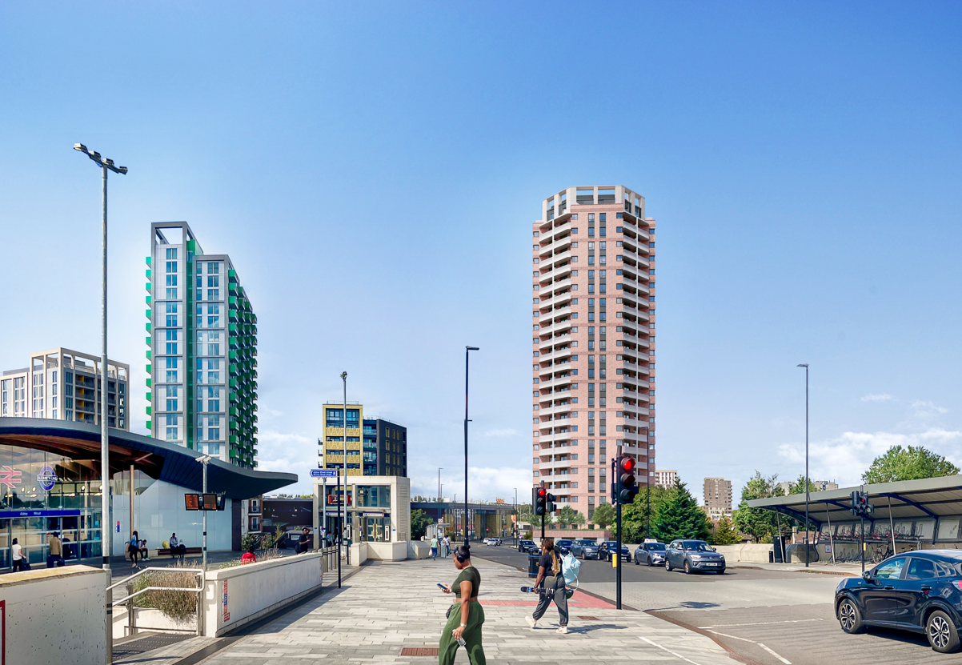
Figure 1 CGI of Proposed Development.
    - The Proposed Development

The Site falls within the Abbey Wood and South Thamesmead Opportunity Area, identified for significant housing and job creation within the London Plan.
The Site extends to approximately 0.272 hectares (ha). The Site is located in the Thamesmead East ward.
The Site is bordered by Harrow Manorway to the west, Overton Road and BP Garage to the north and Sedgemere Road to the east. To the southern boundary there are a collection of trees and residential buildings, further beyond is the Station Car Park.
The area to the east of the Site is made up of predominantly residential buildings, to the west is a mixture of residential, office, a supermarket and Abbey Wood Station.
The Site is currently being used as a trade counter, car repair garage and ancillary storage space. The Site is accessed from Sedgemere Road and currently fenced off from Harrow Manorway. The Site is largely level but the Harrow Manorway to the west does begin to incline significantly in front of the Site giving the appearance of the site being sunken. There is an existing footpath between the Site and the wall of the road.
Table 2 Area Schedule
Space type | Area (m²)
Residential | 19,309.9
Commercial | 132.4
Total | 21,589.1

Site context
The Proposed Development provides an opportunity for making a positive contribution to the new standard of residential buildings in the broader London context.
The Ground Floor Plan indicates the scale of the development and the supporting spaces provided to the residential units above.
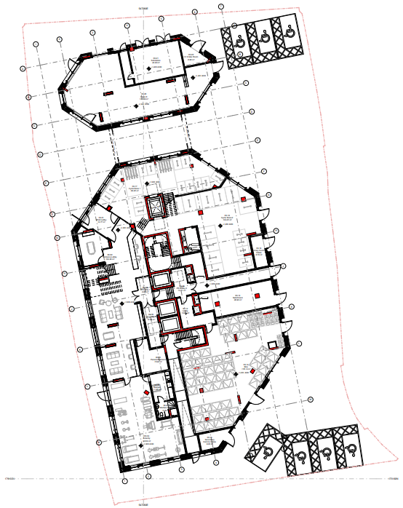
Figure 2 Ground Floor Plan (GRID Architects)

  - Policy driver
The adopted London Plan includes the following policies in relation to the Circular Economy.
    - SI 7 Reducing waste and supporting the circular economy.
7A. Resource conservation, waste reduction, increases in material re-use and recycling, and reductions in waste going for disposal will be achieved by the Mayor, waste planning authorities and industry working in collaboration to:
- Promote a more circular economy that improves resource efficiency and innovation to keep products and materials at their highest use for as long as possible
- Encourage waste minimisation and waste prevention through the reuse of materials and using fewer resources in the production and distribution of products
- Ensure that there is zero biodegradable or recyclable waste to landfill by 2026
- Meet or exceed the municipal waste recycling target of 65 per cent by 2030
- Meet or exceed the targets for each of the following waste and material streams:
  - Construction and demolition – 95 per cent
  - Excavation – 95 per cent beneficial use
- Design developments with adequate, flexible, and easily accessible storage space and collection systems that support, as a minimum, the separate collection of dry recyclables (at least card, paper, mixed plastics, metals, glass) and food.
7B. Referable applications should promote circular economy outcomes and aim to be net zero-waste. A Circular Economy Statement should be submitted, to demonstrate:
- How all materials arising from demolition and remediation works will be re-used and/or recycled
- How the proposal’s design and construction will reduce material demands and enable building materials, components and products to be disassembled and re-used at the end of their useful life
- Opportunities for managing as much waste as possible on site
- Adequate and easily accessible storage space and collection systems to support recycling and re-use
- How much waste the proposal is expected to generate, and how and where the waste will be managed in accordance with the waste hierarchy
- How performance will be monitored and reported.
7C. Development Plans that apply circular economy principles and set local lower thresholds for the application of Circular Economy Statements for development proposals are supported.”
    - D1 London’s form and characteristics.
The Circular Economy Design Principles are also referenced in the “Policy D1 London’s form and characteristics”.
This Circular Economy Statement is based on the GLA’s published guidance document “London Plan Guidance - Circular Economy Statements (March 2022)” which interprets the policies set out above and describes what Circular Economy Statements should include.
    - Bexley Local Plan (2023)
The Bexley Local Plan was adopted in April 2023 and outlines the planning requirements and policies for the area which all new development in the region should adhere to, including the Proposed Development.
The Bexley Local Plan promotes and supports the requirements and targets set out in national and regional planning policy and guidance as well as setting out the boroughs own commitments and methodologies for new construction.
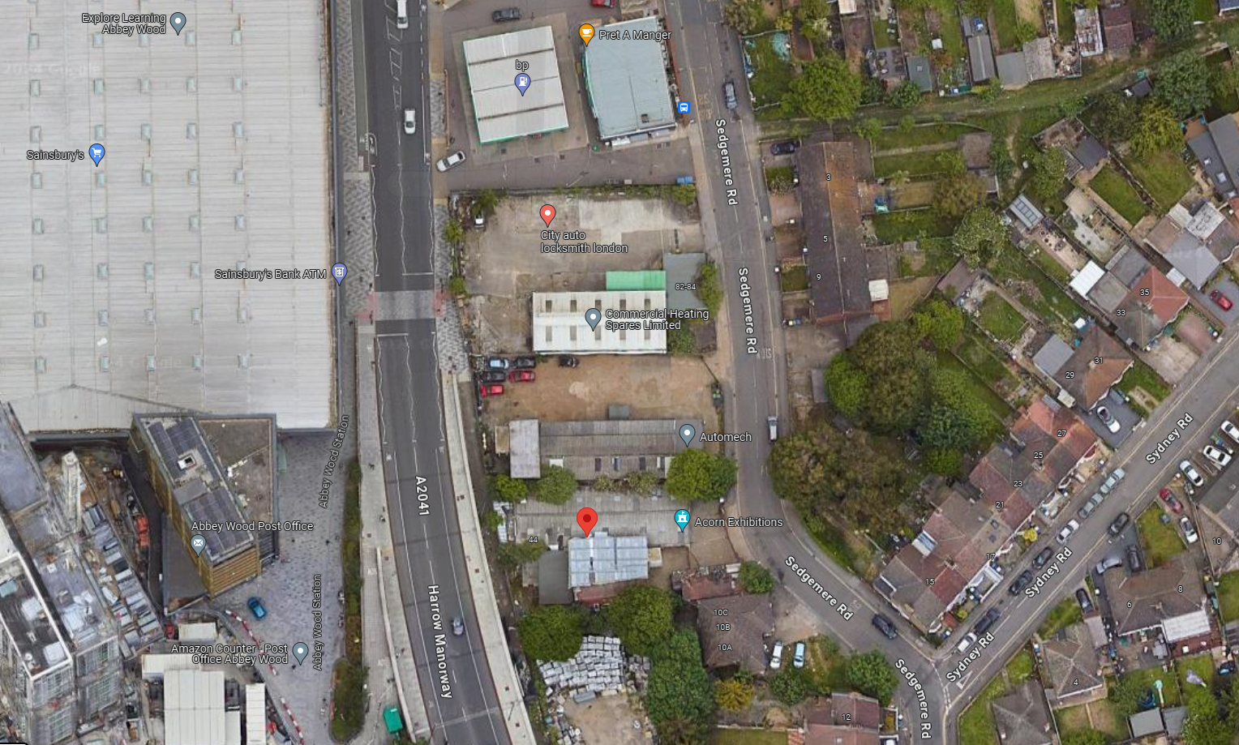
Figure 3: Google image showing location of site within Bexley

The Table below summaries the relevant circular economy policies within the Bexley Local plan.
Table 3 Circular economy and waste management policies contained within the Bexley Local Plan
Policy | Description
Policy SP1 | Achieving sustainable development – the spatial strategy  - Positively pursue sustainable development through providing locally specific requirements.  - work towards achieving sustainable growth in homes, jobs and services to create a network of healthy, well-connected, high-quality, desirable places where people want to live, play, learn and work in line with the vision and objectives of the Council’s key strategies and this Local Plan, thus implementing the principles of sustainable development.  - All new proposals must conform with the following principles:  - Strengthen and diversify the local economy by:  - Reinforcing a network of vibrant successful town centres  - Optimising use of the borough’s industrial land  - increasing inward investment in new high technology and creative sectors.  - promoting circular economy principles and business models; and,  - improving access to jobs in Bexley, London and the wider south east through the development of local skills  - Protect and enhance the natural and built environment by:  - adapting to and mitigating the impacts of climate change, including flood risk;  - focussing new development on urban, brownfield sites in accessible locations; and,  - optimising the efficient management of waste and existing natural resources.  - Create high-quality, safe and well-connected healthy lifetime communities by:  - offering a choice of accessible living styles that appeal across generations; and  - providing necessary infrastructure, local services, open spaces, and cultural and educational facilities
Policy DP 30 | Mitigating Climate Change  - Major development proposals must meet London Plan requirements and calculate whole life-cycle carbon emissions through a nationally recognised Whole Life-Cycle Carbon Assessment and demonstrate actions to reduce life-cycle carbon emissions.  - The Council expects that, where possible new homes be designed to achieve: BREEAM Home Quality Mark (HQM); BREEAM Communities standards (for major housing-led mixed-use development); Passivhaus, or other appropriate sustainability measures
Policy SP 12 | Sustainable waste management  In new development, the Council will ensure that waste is managed in ways that protect human health and the environment and will follow the principles of the circular economy by applying the waste hierarchy. Where opportunities arise, this principle will also be applied to existing development, for example for flats above shops where it can be challenging to segregate waste.  The Council will support sustainable waste management by:  a. implementing the waste hierarchy in its approach to future waste management;  b. meeting its waste apportionments and other requirements, such as the Mayor’s recycling or composting targets, including collaborating with and supporting other London boroughs as appropriate;  c. safeguarding Strategic Waste Management Sites for waste uses as shown on the Policies Map;  d. supporting regionally significant waste management infrastructure, including the Crossness Sewage Treatment Works; and,  e. considering the use of planning contributions, including from the borough’s community infrastructure levy, to provide better waste management for existing development  The Council will support the development of the circular economy by encouraging the waste and construction industries to:  a. make resource use more efficient;  b. reduce the production of waste;  c. maximise the recycling of waste; and  d. identify alternative business models
Policy DP26 | Waste Management in New Developments  All proposals for major development should promote circular economy outcomes and aim to be net zero-waste. Applications should include a circular economy statement in accordance with London Plan policy SI 7 the London Plan.  Residential development proposals that provide additional housing, including conversions, should ensure that:  a. there is adequate space within each flat/apartment for the temporary storage of waste generated by that flat/apartment allowing for the separate storage of recyclable materials;  b. there is adequate communal storage for waste, including separate recyclables, pending its collection;  c. storage and collection systems (e.g. dedicated rooms, storage areas and chutes or underground waste collection systems) for waste are of high-quality design and are incorporated in a manner which will ensure there is adequate and convenient access for all residents and waste collection operatives and will contribute to the achievement of London Plan waste management targets;  d. measures are incorporated to manage, to acceptable levels, impacts on amenity including those that may be caused by odour, noise, and dust;  e. the on-site treatment of waste has been considered and any system to be incorporated will take into account the factors listed above and other relevant Development Plan policies; and  f. adequate contingency measures are in place to manage any mechanical breakdowns  g. there is adequate space within each residential property for the temporary storage of waste generated by that residence allowing for the separate storage of recyclable materials; and  h. there is adequate external storage space for waste, including separate recyclables, pending its collection.  Proposals for new development should be accompanied by a recycling and waste management strategy that considers the above matters and demonstrates the ability of the new development, once occupied, to meet local authority waste management recycling targets

  - Method statement
    - Sustainability strategy
A holistic, interdisciplinary approach has been adopted to define and communicate the sustainability strategy for the Proposed Development.

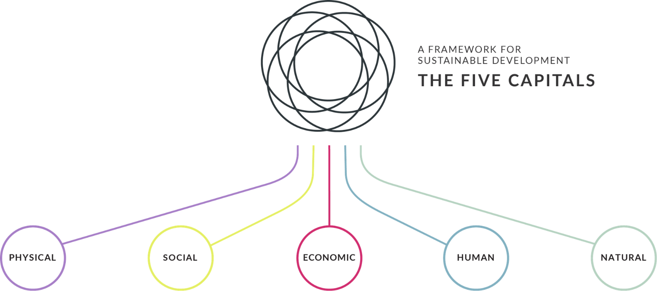
The design of the Proposed Development is based on sustainable design and construction principles as informed by planning requirements and industry best practice. The project has utilised a sustainability framework based on five defined factors; the people, the building, the social network, the natural environment, and the economic aspects to capture the multi-faceted sustainability benefits and values that the development seeks to bring to the application site; local community; surrounding businesses and future building users.

Enhancing the environment
By seeking to achieve positive gain, NATURAL VALUE is increased where existing quality is protected and new complementary resources are introduced.

Physical & mental wellbeing
With a focus on people, HUMAN VALUE is increased where quality and longevity of life is improved and happiness is increased.

Economy & prosperity
By ensuring equity for all, ECONOMIC VALUE is increased where all users of a place feel they have a level of ownership of the asset and buy-in to the outcomes it is seeking to achieve.

Community & place
By enabling community identity, SOCIAL VALUE is increased where a great place brings people together, and creates a community.

Form and mobility
Creating high quality buildings ensures PHYSICAL VALUE is increased where the development projects an image of design for longevity and allows people to navigate easily on foot/by bicycle.

Circular economy aspirations
Consumption of natural resources has historically followed a linear approach, heightened by the industrial revolution which, while lifting the living standards of millions, also dramatically increased pressure on environmental resources. Under the traditional ‘take > make > use > dispose’ model, raw materials are collected, then transformed into products that are used until they are finally discarded as waste. Apart from failing to capture value over the lifetime of products, this approach also produces a range of negative externalities that include resource scarcity, unsustainable levels of water extraction, rising carbon emissions, and widespread ecosystem pollution.
In a circular economy, built environment assets are designed so that whole buildings, and materials, components and parts can be continually and easily recycled.
The built environment sector is a major consumer of natural resources. There is growing industry consensus that the way we design, build, operate and dispose of our buildings and associated facilities needs a major overhaul to obviate waste and increase efficiency. There is an incredible breadth of opportunity that this shift in approach will create across the entire supply chain.
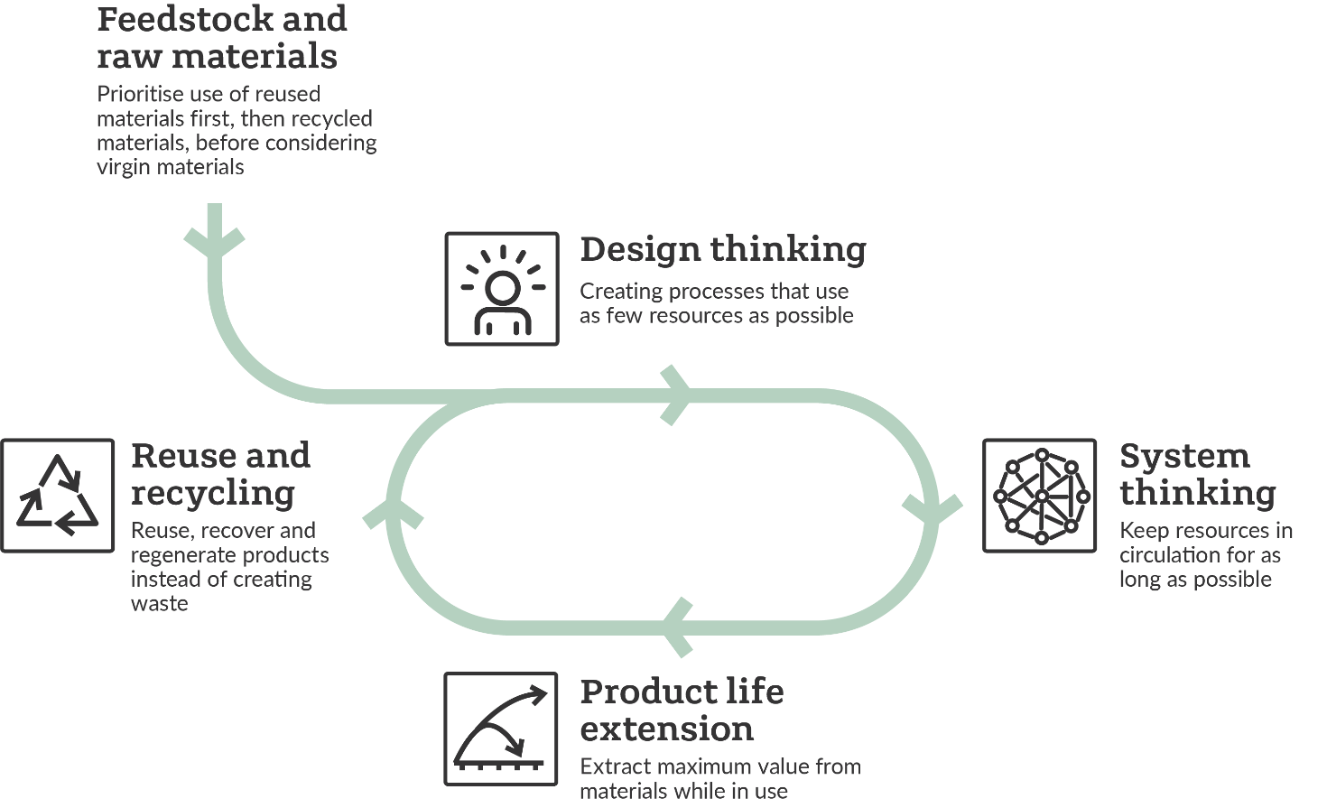
Figure 4: Circular economy approach
Circular Economy considerations have formed a key part of the project sustainability strategy, given the scale of the Proposed Development, and the client’s wider sustainability aspirations. It is recognised that in order to implement Circular Economy principles most effectively, it is helpful to explore strategic opportunities as early in the Proposed Development process as possible.
Considerations around resource efficiency, material circularity and ethical sourcing have been considered within the overarching sustainability strategy from the early stages.
It is acknowledged that the approach to Circular Economy will evolve as the design evolves, or in response to wider considerations and feedback from key stakeholders.
As a site-wide strategy, the project has formulated commitments around the promotion of sustainable use of materials comprising several targets around materials and waste including priority given to renewable construction materials such as timber, diversion of construction waste from landfill, maximising the use of recycled or secondary aggregates giving preference to solutions available closer to the site, construction resource efficiency and an overarching ambition to reduce the project’s supply chain carbon intensity from materials and manufacturing relative to standard industry performance to be achieved through measures including:
- “Smart” material choices (prioritisation of durable, biodegradable, recycled / recyclable materials and materials that can be reused or re-purposed, where possible)
- Incorporation of modular elements for higher levels of design flexibility and adaptability
- Procurement of products as a service – leasing access to a solution instead of buying it
- Product life extension through improved maintenance, remanufacturing, repairing and upgrading / upcycling
- Closed loop / Take back – working with manufacturers who take back used products to recover the value by using them to make new products.
An effective incorporation of circular economy principles represents an opportunity for the site and the UK as a whole. With its system-wide perspective, the circular economy has the potential to help us make better decisions about resource use, design out waste, provide added value for business and society, and proceed along a secure route to society-wide prosperity and environmental sustainability for future generations.
While specific values and levels of ambition / benchmarks have been defined for some of the metrics, it is recognised that these are preliminary targets and commitments which will be reviewed and may be adjusted as appropriate during the detailed design to respond to the specific requirements of each element and ensure that current best practice is being followed and opportunities to innovate are maximised.
There is a clear understanding that, in order to achieve the ambitious objectives set for the project, the design team will have to engage and collaborate extensively with the supply chain to foster knowledge sharing and fast track innovative ideas and techniques spanning the design, construction and operation stages thus enabling synergies.
    - Circular economy strategy process
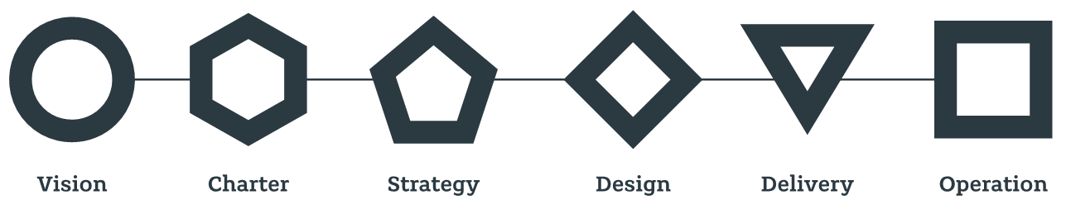
Figure 5: Sustainability Strategy – Delivery Phase (Inception to Completion).
The following process has been followed in developing this strategy:
- Working with all key stakeholders, an overall sustainability vision for the development has been defined and agreed.
- A series of sustainability workshops have been held during the concept design stages, in collaboration with the client and project team to help define the sustainability strategy.
- The sustainability strategy, based on the five capitals framework, defines the project vision, themes and intended outcomes. Circular economy aspects are captured within both natural and physical capital.
- Circular economy principles have been reviewed by the project team as part of this process, specifically in relation to the physical capital.
- Sustainability certification is also being pursued, in the form of HQM assessment of the site. A HQM pre-assessment exercise has been undertaken via workshops in conjunction with the project team. This exercise has assisted in more detailed consideration of specific targets for these elements of the scheme.
- Additional workshops will be held during the detailed design stages to explore further opportunities to incorporate key Circular Economy principles into aspects of the design, procurement, and construction process.
- As the proposals move toward the construction stage, early engagement will be sought with contractors to assist in refining strategies for delivery. Initial documentation that has been/will be prepared to aid this are:
  - An audit has been undertaken for the development to gauge which elements of the existing structures and hardstanding on site can be retained, reused, reclaimed, or recycled.
  - A Sustainable Procurement Plan will be developed, setting out aims and targets for procuring products sustainably and locally where feasible.
- Robust data collection plans will be implemented through design and construction to facilitate ongoing monitoring against intended outcomes.
- Given the scale of the development and the likely nature of the construction programme over several years, it is expected that the strategies and approach will evolve over time.
- Circular economy targets
The following table details the minimum target for waste arising and recycling throughout the project, which follow the policy requirements.
Table 4 CE targets
Circular economy targets for existing and new development | Policy requirement | Target (%) | Policy met? | How will performance against this metric be secured through design, implementation, and monitoring?
Demolition waste materials (non- hazardous) | Minimum of 95% diverted from landfill for reuse, recycling or recovery. | 95% | Yes | A pre-demolition audit has been completed which highlights the reuse and recycling routes for the existing materials on site.
Excavation waste materials | Minimum of 95% diverted from landfill for beneficial reuse. | 95% | Yes | The excavation waste requirements and targets will be provided to the contractor prior to works beginning.
Construction waste materials | Minimum of 95% diverted from landfill for reuse, recycling or recovery. | 95% | Yes | The construction waste requirements and targets will be provided to the contractor
Municipal waste | Minimum 65% recycling  rate by 2030. | 68% | Yes | Waste storage details and recyclable values can be found in the Delivery, Servicing and Waste Management Plan by Steer. Details of these values with a possible further requirement will be confirmed at RIBA Stage 4.
Recycled content | Minimum 20% of the building material elements to be comprised of recycled or reused content. | 20% | Yes | Recycled content requirements will be detailed in tender documentation and confirmed during detailed design RIBA Stage 4. At this stage a minimum overall percentage of 20% is targeted, but this is expected to be improved upon during detailed design and following workshops and discussions with the supply chain.

- Circular economy design approach
Circular Economy considerations have formed a key part of the project sustainability strategy. It is recognised that in order to implement Circular Economy principles most effectively, it is helpful to explore strategic opportunities as early in the development process as possible.
As discussed earlier, a series of sustainability-focused workshops were held in collaboration with the client and project team to help craft a holistic and consistent sustainability approach for the development. Considerations around resource efficiency, material circularity and ethical sourcing have been a critical element of the overarching sustainability strategy.
It is acknowledged that the approach to circular economy will evolve as the design evolves, or in response to wider considerations and feedback from the GLA or other stakeholders. The edited decision tree below shows the recommended design strategy and the following pages elaborate on the design approaches assessed. Further information is available in the Design and Access Statement (Appendix A).

Decision tree for design approaches for existing structures/ buildings
Is the existing building, or parts of the building, suited to the requirements for the site?
Is there an existing building on site?
Retain and Retrofit
YES
Partial Retention and Refurbishment
Is it technically feasible to recover the residual value of the building elements or materials
Demolish and recycle
NO
Disassemble and Reuse
YES, in Part
Is it technically feasible to retain the buildings in part or in full?
Are there any building Materials or elements available on site that can be used?

YES
NO
YES
NO
NO
YES
Reuse/recycle on a site nearby
Reuse/recycle off-site
Reuse/recycle on site
NO
New Building
YES, in Whole
Least preferable
Most preferable
Figure 6: Decision Tree for Whole Life Carbon Strategy showing routes considered and the approaches representing them, with the green lines indicating the proposed design route.

  - Existing Site
The Site is currently being used as a car repair workshop and ancillary storage space. The Site is accessed from Sedgemere Road and currently fenced off from Harrow Manorway. The Site is largely level but the Harrow Manorway to the west does begin to incline significantly in front of the Site giving the appearance of the site being sunken. There is an existing footpath between the Site and the wall of the road.
Velocity have prepared the pre-redevelopment and pre-demolition audits, in which they describe the existing buildings shown in Figure 7 as below.
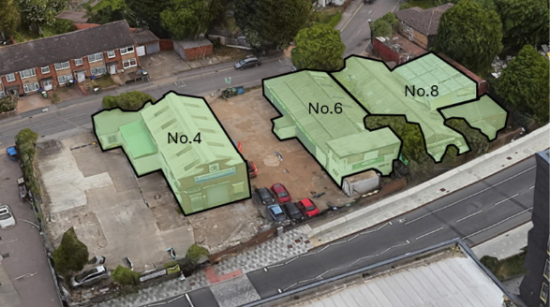
Figure 7 Photo of existing site highlighting the existing structures (Velocity Pre-redevelopment audit)
4 Sedgemere Road is a 2-storey storage facility for a commercial heating company, with two smaller low-level extensions to the north. The structure comprises a concrete ground slab, breeze block and concrete frame, brick facades and roller shutter doors. The roof is described as box cable corrugated metal.
6 Sedgemere Road is a car repair workshop on a concrete slab with engineering brick walls, roller shutter doors and a corrugated metal sheet roof.
8 Sedgemere Road is a storage facility for an exhibition company accessed via large steel concertina sliding doors. The structure is anticipated to comprise typical masonry (brick) construction on concrete slab hardstanding, with a box gable and skillion corrugated metal roof, plus flat asphalt roof.
    - Pre-redevelopment audit.
The Pre-redevelopment audit (PRA) has been prepared in accordance with the Greater London Authority (GLA) Circular Economy Guidance to understand whether elements of the existing structures on site can be retained, refurbished, or incorporated into the site.
The scope of the PRA includes an assessment of a number of structures, including a car repair workshop, ancillary storage space and workshop buildings surrounded by hard standing.
The PRA considers three scenarios for the existing buildings and structures:
- Light refurbishment: reuse of the existing structures on site in their current form with cosmetic enhancements and additional minor repairs to the fabric of the building as necessary. No significant structural changes, but full strip out and replacement or upgrade of individual elements such as glazing and Mechanical, Electrical and Plant (MEP) systems where feasible to facilitate any proposed change of use.
- Refurbishment and extension: reuse of the existing structures on site with horizontal extension. Improvements may include removal of existing features to facilitate addition of new elements. Refurbishment work as per light refurbishment scenario.
- Full redevelopment: full demolition of structures to ground level to facilitate construction of a new building
A high-level whole life carbon study was conducted to provide a quantifiable assessment of each scenario as tabulated below.
Table 5 Whole life carbon assessment
 | Whole life carbon (kgCO₂e/m²)
Scenario | Commercial | Residential | Total
1 | 1,178 | - | 1,178
2 | 625 | 566 | 589
3 | 761 | 585 | 586

The audit states that Scenario 1 is unsuitable to take forward and should be disregarded. Whilst scenario 2 is only marginally worse performing with regard to WLC than Scenario 3, it does not meet the development brief and would likely be economically unviable. Scenario 3 is considered to be the only viable option, with the lowest WLC per sqm of the three options.
Further detail behind the recommendations and WLC modelling can be found in the report [Ref: 240607 Sedgemere Pre Redevelopment Audit DRAFT 0.1].
    - Pre-demolition audit.
The Pre-demolition audit has been prepared by Velocity to identify and quantify the key materials and components in the existing buildings, structures and landscaping that could be re-used or recycled once all furniture and loose items have been removed.
The audit recommends that the contractor responsible for the demolition process should approach it from the perspective of a circular economy, prioritising re-use on site before recycling, in line with the waste hierarchy.
The existing structures limit opportunities on site to create spaces of the desired quality suitable for the proposed residential and commercial uses.
Deconstruction of 4, 6 and 8 Sedgemere Road is considered unfeasible due to the low-quality nature of the buildings and that their construction does not facilitate repurposing of specific elements or reclamation of materials. Demolition is deemed to be the only viable option.
Nonetheless, the following items have been highlighted as having potential for re-purpose:
- Roller shutter doors from 4 and 6 Sedgemere Road could be demounted for refurbishment and reuse on another project nearby
- Bricks from the external walls could be recovered for reuse
Where elements of the buildings on site are not suitable for reuse, they are identified for demolition and recycling. Velocity have estimated the weight of materials generated by this process and assume best practice off-site recycling, with unrecyclable material being diverted from landfill. The overall recycling rate for demolition waste generated on site is estimated to be 99.91%.
Key demolition products include inert materials and mixed materials. The inert materials include:
- Floor slabs
- Structural building frames
- External facades
- Areas of hard standing
As the potential for reclamation of inert materials is relatively low due to their use, composition and quantities, they are expected to be recycled to form secondary aggregate either on- or off-site. Whilst on-site crushing is more efficient, the small footprint of the site and its proximity to neighbouring residential properties may lead to off-site crushing, but this will be explored as part of a site logistics strategy.
The mixed materials include metals, with use across all structures for a number of purposes:
- Structural building frames
- Doors and windows
- External fixings
- Floors
- Roofs
- Pipes and ducting
Segregated containers are recommended for the metal generated by the demolition process to enable scrap metal recycling. Scrap metal has a value by weight and will generate a rebate based on the quantity of material.
Velocity have calculated the embodied carbon from the demolition of the site using the ICE Database as summarised in Figure 8 below.
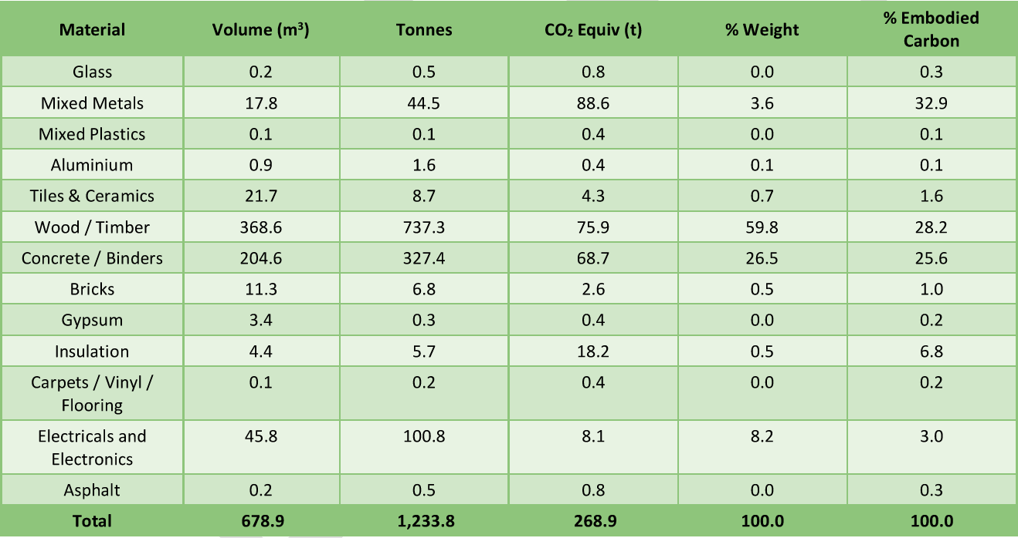
Figure 8 Embodied carbon arisings from demolition waste (Velocity Pre-demolition audit)
Further detail behind the recommendations and modelling can be found in the report [Ref: 240607 4-8 Sedgemere Road Pre-Demolition Audit Draft v0.1].

- Proposed strategy for the proposed building.

Strategy for New Building Layers
The circular economy strategy for the new building layers addresses the following design approaches, split out into each layer as indicated on Figure 9. Each layer has been considered along the decision tree for the most appropriate pathways. However, regardless of the pathway taken, all developments should consider the following circular economy design principles: Design out waste; Design for flexibility; Design for adaptability; Design for disassembly; Design for material reuse/ recycling; Design for longevity.
The following strategies have been applied to the chosen design – Partial Demoltion, Refubrishment and New Build.
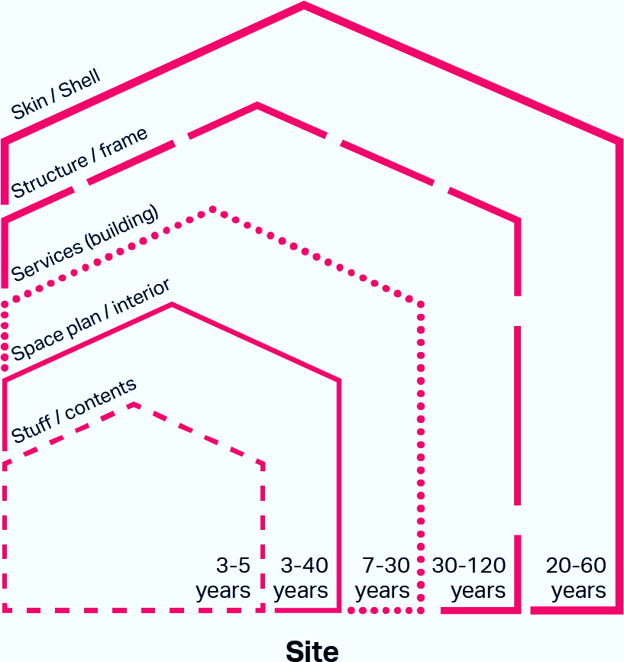
Figure 9: Building Layers and Standard Lifespans (Source: GLA)
NO
Is there likely to be a need for buildings of similar size (etc.) in difference locations in the future?
Is the whole building designed to have a short life on its current site (< 10 years)?
Design for Building Relocation
Design for Component/ Material Reuse
NO
YES
YES
NO
Is it foreseeable that the building will need to change use/ function within its design life?
Design for Adaptability
YES
Design for Longevity
Table 6: Building layer summary (Source: GLA)
Building layer | Summary and constituent elements
Site | The geographical location, context, external works, earth works and landscaping.
Skin/shell e.g., façade | The layer keeping out water, wind, heat, cold, direct sunlight, and noise. Includes exterior surfaces such as the roof, siding, sheathing and windows. This layer includes the façade (front or face of a building).  This layer often has biggest impact on long- term durability, occupant comfort and building-energy performance.
Structure/ structural frame/ superstructure | Load-bearing elements above plinth including roof-supporting structure. Generally, it is the longest-lasting building element. Insulation and services may be embedded here.
Substructure | Excavations, foundations, basements, and ground floors.
Services (building) | Installations to ensure comfort, practicality, accessibility, and safety, including plumbing, heating, cooling, ventilation, and electrics.  Distribution systems can be hard to change.
Space/space plan/interior/ interior space | The layout, internal walls and partitions, ceilings, floors, surface finishes, fixtures, doors, fitted furniture. Changeable without changing structure, services, or skin.
Stuff/contents | Anything that could fall if the building was turned upside down. Not permanent, easily movable, most frequently changed by occupant, e.g., appliances, lamps, electronics, furniture, art.
Construction materials | Any temporary installations/works/materials, packaging and equipment.
    - Skin/Shell
Is it likely the layer (or components within it) will need to be moved or otherwise modified within 5-15 years, e.g., due to changing use patterns or user requirements?
Design for Flexibility
NO
YES
NO
Is it likely the layer (or components within it) will need to be changed, upgraded, or replaced within 5-15 years, e.g., for improved performance, aesthetics?
Design for Replaceability
YES
Design for Adaptability

New Building Circular Economy Design Approaches implemented:
- The removability of the façade promotes replaceability and adaptability. This will extend the building life span and allow for a future change in use as the façade can be easily upgraded and modified as and when required. (Design for replaceability and adaptability)
- The façade design should be driven by a similar discipline and rigour as applied to the general arrangement of the building and achieve an ordered composition that reflects the standardised nature of the module setting out. A repeatable façade bay of a consistent material language has been incorporated which provides benefits in terms of compatibility with the construction method as well as cost optimisation.
    - Structure/Frame

Is it likely the layer (or components within it) will need to be moved or otherwise modified within 5-15 years, e.g., due to changing use patterns or user requirements?
Design for Flexibility
NO
YES
NO
Is it likely the layer (or components within it) will need to be changed, upgraded, or replaced within 5-15 years, e.g., for improved performance, aesthetics?
Design for Replaceability
YES
Is the layer (or components within it) designed to last the building’s 60-year life span?
Design for Longevity
Design for Adaptability
NO
YES
New Building Circular Economy Design Approaches implemented:
- The design team intend to use a concrete frame supported by steel rebar. There is potential for the use of reused and recycled concrete and steel, which will reduce the need for virgin materials and extend the lifespan of building materials. (Component or material reuse).
- The structure is to be designed for at least a 60-year life span however, theoretically the Proposed Development should remain beyond this. Assessment of the extreme weather actions including flooding will be reviewed as a part of the design and incorporated. (Longevity).

    - Services (building)
Is it likely the layer (or components within it) will need to be moved or otherwise modified within 5-15 years, e.g., due to changing use patterns or user requirements?
Design for Flexibility
NO
YES
NO
Is it likely the layer (or components within it) will need to be changed, upgraded, or replaced within 5-15 years, e.g., for improved performance, aesthetics?
Design for Replaceability
YES
Design for Adaptability

New Building Circular Economy Design Approaches implemented:
- As the development is a new build, the building services are unlikely to need modifying, replacing or upgrading in the 5-15 years following completion as it is expected the services will be up-to-date and reflect modern technology at that time.
- Wherever possible, service distribution and on-floor services zones will be standardised to enable efficient design, installation, and adaptability. (Design for adaptability)
- A large portion of MEP services by their nature are easily dissembled and recyclable when they reach the end of their economic lifetime. Adequate access throughout the building will be provided to ensure ease of adaptability and disassembly at end of life. (Design for replaceability/ disassembly / Component or material reuse).
- The building services are accessible allowing for maintenance and replacement when required, and are designed to ensure minimal damage to the component during assembly, providing opportunities for re-use and recycling. (Design for replaceability/ disassembly / Component or material reuse).
- There are opportunities to move and redistribute building services, allowing for future changes in building use type and extending the building lifespan. (Design for adaptability)
- Additionally, as an all-electric heating solution is being implemented the phase out of fossil fuels will not impact the development. (Design for adaptability)
    - Space Plan/Interior
Is it likely the layer (or components within it) will need to be moved or otherwise modified within 5-15 years, e.g., due to changing use patterns or user requirements?
Design for Flexibility
NO
YES
NO
Is it likely the layer (or components within it) will need to be changed, upgraded, or replaced within 5-15 years, e.g., for improved performance, aesthetics?
Design for Replaceability
YES
Design for Adaptability

New Building Circular Economy Design Approaches implemented:
- All amenity space has been designed to be as flexible as possible and could allow for a future change in use (Design for flexibility).
- Retail areas are specified as shell and core which allows for flexible use of the spaces for a wide variety of tenants. (Design for flexibility).
- Plywood to be used as part of the internal partitions. This material has high re-use and recycling opportunities, when initially selecting the materials at design stage and at the end of building life.
    - Stuff/Contents
Is it likely the layer (or components within it) will need to be moved or otherwise modified within 5-15 years, e.g., due to changing use patterns or user requirements?
Design for Flexibility
NO
YES
NO
Is it likely the layer (or components within it) will need to be changed, upgraded, or replaced within 5-15 years, e.g., for improved performance, aesthetics?
Design for Replaceability
YES
Design for Adaptability

New Building Circular Economy Design Approaches implemented:
- The furnishings within the Proposed Development will generally be completed by tenants following completion of the construction stage. It is unlikely the furnishings will be permanent and can be easily removed with no damage to building components. (Design for flexibility)

  - End-of-life strategy
A detailed end-of-life strategy will be produced prior to construction to describe how building materials, components and products can be disassembled and re-used at the end of their useful life. This will include how the information will be communicated to future building users. The end-of-life scenarios will align with the assumptions of lifespans and recyclability made in the bill of materials/ whole-life carbon assessment. The following will be set out:
- How the end-of-life strategy will be communicated with future building owners, managers and occupiers.
- How the building information will be stored during the building’s life, e.g., through a BIM model or material passports, to facilitate disassembly and identify any key challenges.
- Additionally, plans for disassembling each building element/ layer, specification of materials and products that have been specifically designed for disassembly, or are certified as having met circularity criteria such as Cradle to Cradle certification.
The key priority of this development is to create a building that has an extended lifetime due to careful design and specification to ensure flexibility and adaptation. The design also aims to ensure that if the building is to be deconstructed at a later date that there is a clear process to follow.
The design of the building will seek to reduce material demands and enable building materials, components, and products to be disassembled and reused at the end of their useful life.
Design for disassembly will also be explored for interior fit-out elements at later stages of the design to allow for ease of replacement and facilitate material recovery at the end-of-life of the building. Further, the design will look to consider efficient design solutions including increasing the utilisation factor of structural members; designing to standard material dimensions to reduce off-cuts and waste on site and allow for future reuse; and removing redundant materials from the design.
This approach, alongside on-going monitoring of energy, water, and transportation, will subsequently result in less of a demand being required for required resources. Finally, the scheme will be designed to accommodate an adaptable, flexible, and reusable design in the future, accommodating to potential change in use building services, as well as building user demands.
In support of the end-of-life strategy, documentation, will be made readily available by the design team (incl. Building User Guides (BUG), Building adaptability and disassembly guide) for the building occupants, tenants, and Facilities Management (FM) team in order to inform them on the end of strategy, disassembly, future reuse, waste avoidance and waste reduction principles which have been adopted and incorporated into the base build. These documents will also include the building drawings as well as manufacturer guidance. This information will facilitate the building occupiers in understanding how the building elements work, and appropriate management methods to adhere too. Table 5 summaries the design principle and the end-of life strategy for key building components of the proposed development.
Table 7 Summary of End-of-life strategies for key building component
Building component | Design principle | End-of-life strategy
Substructure and Superstructure | Designing for longevity and adaptability | Building re-use/change in use; deconstruction and material reuse and/or recycling.  Materials such as concrete, glass, steel, and other metals can be recovered at end-of-life for reuse and/or recycling.
Facade | Design for longevity, disassembly, replaceability, adaptability | Material and component recovery, reuse and/or recycling.  The pre-cast concrete slabs are manufactured offsite and fitted onto the building, allowing for disassembly or replaceability at the end of component life.  Standardised design and mechanical fixings will be preferred where possible to enable this.
Interior fit-out | Material efficiency; Design for Disassembly and maintainability | Material and component recovery, reuse and/or recycling.  Use of durable and demountable interior fit-out will allow for components and materials to be recovered and reused on-site. Alternatively, the option to share reusable materials with other buildings and charities can also be explored.
Building services | Efficient design; Design for longevity and maintainability | Refurbishment, reuse and/or component and material recovery and recycling.  The building services will be designed and maintained to prolong their expected service life. Ease of access and independence of building services will enable building services to be replaced without major disruptions to the building.

- Opportunities for managing and reducing waste
  - Operational waste management plan
An operational waste management plan has been produced to demonstrate that the proposed development has adequate, flexible, easily accessible, and shared storage space and collection systems. Waste collection vehicles will service the development in line with the procedures set out by the London Borough of Bexley.
A different approach is expected for the residential and commercial units to meet the needs of both demises, as outlined below:
- Within the residential units, residents will be responsible for segregating and storing their refuse and recycling in their kitchens using the storage facilities provided. Each apartment block will have a communal waste storage room comprising Eurobins for the identified waste streams
- The commercial units are currently designed to retain flexibility and their fit out will incorporate the tenant’s fit out of their required waste storage to meet their specific demands and requirements. As with residential waste, the tenants will initially be expected to segregate and store their refuse within their own designated waste store area. All waste storage areas will be clearly labelled to ensure cross contamination of waste between streams is minimised.
Commercial and residential waste will be segregated.
  - Waste during construction
Waste management during both excavation and construction periods will be undertaken in accordance with the project Environmental Statement for managing the environmental impact from enabling and construction.
Waste management procedures and documentation information will be covered within the Site Waste Management Plan (SWMP) prepared by the contractor, identifying the types and quantities of waste produced during every stage of the project, as well as opportunities to reduce, reuse and recycle construction process waste. A waste hierarchy approach will be followed with the intention first to minimise waste generation, followed by reuse or recycling off-site.
To facilitate minimising on-site waste generation:
- Materials suppliers will agree to reduce packaging, to use reusable packaging, or to operate a packaging take-back scheme;
- ‘Just-in-time’ material delivery to minimise stockpiling and related risk of damage and disposal as waste;
- Close attention to material quantity requirements to avoid over-ordering and generation of waste;
- Segregation of waste at source where practicable.

Contractor energy use on and off-site will be minimised where possible:
- Using alternatives to diesel/petrol powered equipment;
- Incorporating sources of renewable energy, to offset the use of main utilities;
- Selecting and specifying energy efficiency plant and equipment; and
- Implementing staff training for initiatives to turn off plant and equipment when not in use.

The energy consumption of the project will be monitored, through submetering or reading of utility bills, to allow comparison against best practice benchmarks, and improved where possible.
As part of understanding the impact of the construction periods the Construction Environment Management Plan will illustrate indicative construction vehicle routes.
In addition, vehicle routes to recommended demolition waste processing plants will be indicated, with a focus of these to be located within Greater London, minimising vehicle distances to travel, and such impacts of these vehicles on the surrounding environment.
  - Plans for implementation
Velocity have prepared an outline Site Waste Management Plan [Ref: 240626 4-8 Sedgemere Road SWMP DRAFT ISSUE v0.1] which includes a section on circular economy considerations highlighting the following project objectives:
- London Plan Policy SI 7: 95% reuse/ recycling/ recovery or construction and demolition waste material streams and 95% excavation waster sent for beneficial use
- No more than 5% demolition, excavation or construction waste will be sent to landfill
- The developer will be contractually responsible for all site waste reporting, tracking progress against targets
During the design stage, the commitments and targets outlined in this report will be subject to on-going review by the majority of the design team members. Key responsibility has been summarised within each of the principles, outlining how they plan to progress with each principle and ensure the aspects are captured within the final build design. It will be the responsibility of the Sustainability consultant to lead the conversation on Circular Economy and the principles within the design, this will be documented and monitored via updated proforma templates, drawings, and correspondence.
Prior to the commencement of works on site, an updated Detailed Circular Economy Statement will be submitted to document the progress that has been made between Stage 2 and Tender, confirming the principles and design aspects included, as well as the lessons learnt, and challenges faced by the team within the process.
This process will be repeated again following the construction of the development, reporting on the strategies and commitments implemented by the Principal Contractor and their team in line with the approach made throughout the design stage. Final evidence including the following as listed below will be provided in order to confirm how the development has and will perform throughout its life cycle.
- Evidence of audits.
- Written agreements or correspondence.
- Final SWMP and or RMP.
- Drawings or photos.
- Specifications.
- Updated versions of Table 6 and 7.
- Bill of Materials.
In the long-term appropriate documentation, will be made readily available by the design team (incl. Building User Guides (BUG), Building adaptability and disassembly guide) for the building occupants, tenants, and FM team in order to inform them on the end of strategy, disassembly, future reuse, waste avoidance and waste reduction principles which have been adopted and incorporated into the base build.

Table 8 Outline plan for implementation
RIBA stage | Action | Responsibility | Evidence |  | Status:
0-1 | - Set broad objective for circular economy aspirations | Client; Project Manager; Design team; Sustainability consultant. | - Project Brief  - Design team meeting minutes  - Design and Access statement. |  | Completed
0-1 | - Assessment of the site | Client; Project Manager; Contractor | - Pre-development audit  - Pre-demolition audit |  | Completed
0-1 | - Develop objectives with specific metrics | Client; Project Manager; Design team; Sustainability consultant. | - Circular Economy statement  - BREEAM pre-assessment |  | Completed
0-1 | - Identify further information required | Cost consultant; Design team; Sustainability consultant; Project manager | - Design development notes |  | Completed
2-3 | - Hold workshop to investigate circular economy alternative approach | Client; Project Manager; design team including architects, structure engineers, façade designer; waste consultant; cost consultants, sustainability consultant; | - Circular Economy statement  - Meetings  - Design development drawings and reports  - Site waste management Plan  - Resource Management Plan  - Operational Waste Management Plan |  | Completed
2-3 | - Agree opportunities, commitments, and metrics/ targets. |  |  |  | Completed
4 | - Include metrics as clauses within procurement packages | Client; Project Manager; Contractor; Design team; Sustainability consultant. | - Tender documents and specifications  - Contractor and supply chain written agreements | To be commenced
4 | - Monitor design against metrics, continue to engage with suppliers |  | - Detailed design drawings and reports  - Design specifications  - Value engineering studies  - Cost Plan/Bill of Quantities  - Supply chain interaction correspondence evidence
5 | - Monitor metrics with contractor and supply chain | Client; Project Manager; Contractor | - Procurement receipts/invoices  - Waste receipts  - Site photos  - Technical specification documents and drawings. | To be commenced
5 | - Continue to investigate alternative materials/products | Client; Project Manager; Contractor; Design team; Sustainability consultant. | - Design team, Contractor, and supply chain correspondence evidence.  - Material optioneering reviews.
6 | - Review success against objectives | Client; Project Manager; Contractor; Sustainability consultant. | - Procurement receipts/invoices  - Waste receipts  - Site photos  - Performance and test certificates  - Technical specification documents and drawings. | To be commenced
6 | - Post completion circular economy statement and reporting |  | - As built information  - Services commissioning and testing  - Building User Guides (BUG)  - Building adaptability and disassembly guide  - Site photos  - Post completion circular economy statement

- Conclusion.
The Circular Economy approach and commitments for 4-8 Sedgemere Road have been developed through a collaborative and interdisciplinary approach. The interventions proposed aim to embed sustainable practice, waste reduction and circular economy principles within the built environment.
This statement outlines how the design approach prioritises Circular Economy principles, helping to reduce the material impact and waste generated by the built environment.
As summarised within, several studies have been undertaken by the project team, confirming that a new build scheme is the best approach to redevelopment of the site to achieve the project aims.
Site clearance would maximise development density, adhere to planning policy aspirations and optimise building performance and operational carbon emissions. The demolition process would generate the highest level of embodied carbon but enable additional storeys to deliver the development brief, increasing efficiency per square meter.
The pre-redevelopment audit confirms that a full development scenario would offer the most benefit; despite the generation of 1,233 tonnes of demolition waste, full development was shown to generate the lowest WLC emissions.
The pre-demolition audit identified materials for salvage and re-use as part of the development proposals, in line with the waste hierarchy and circular economy principles.

Appendix
Written evidence that the destination landfill(s) have the capacity to receive waste
The waste strategy has been devised based on the similar building operations and understandings of the waste requirements of similar sites.
Site Waste / Resource Management Plan
As per Outline SWMP, Velocity.
Municipal / Operational Waste Management Plan
Delivery, Servicing and Waste Management Plan, Steer
Cut and fill calculations and/or Excavated Materials Options Assessment
A cut and fill evaluation is anticipated to be provided during a later design phase (stated in outline SWMP)
Scenario modelling demonstrating adaptability
No further supporting material is currently available.
Additional supporting material will be provided as part of a revised Circular Economy Statement at RIBA Stage 4 / Pre-construction.
Other supporting material depending on project characteristic:
Pre-redevelopment audit, Velocity.
Pre-demolition audit, Velocity.
Circular economy workshop evidence
Slides used during the circular economy workshop carried out on 12th Feb 2024 are shown below.
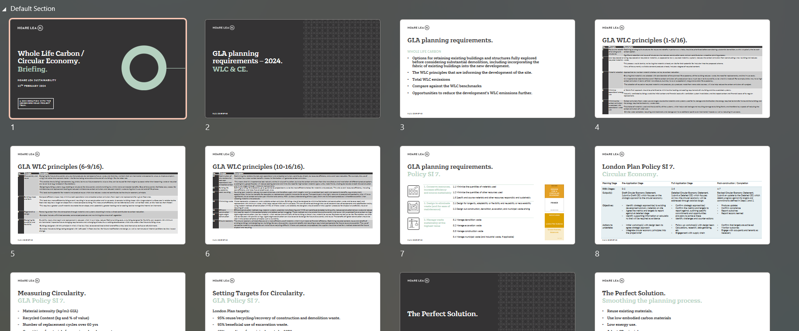

Circular economy workshop evidence
See below excerpt from the Oneclick Circularity Tool output, which shows that the recycled content of the design is ~25.65%. This will be reviewed and updated as appropriate through the design process.
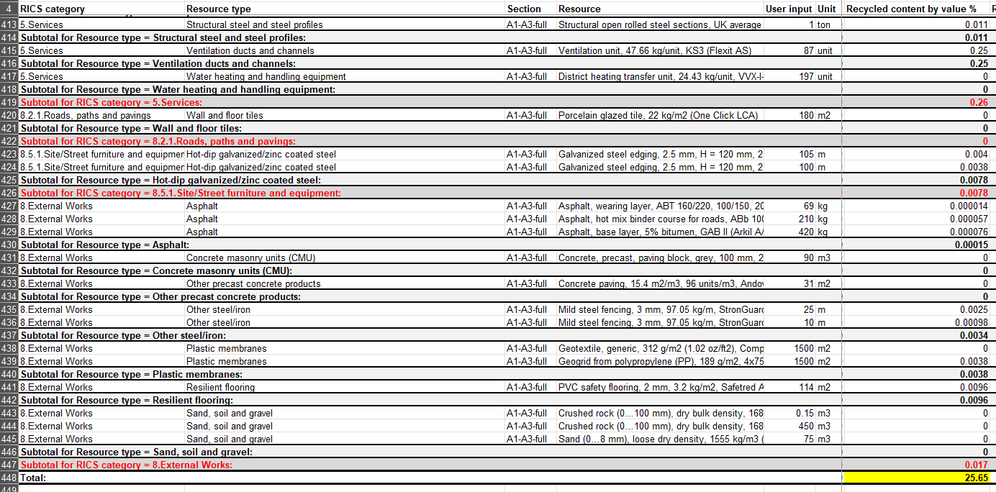

JAMES ROBB
SENIOR ASSOCIATE

+44 141 471 0025
jamesrobb@hoarelea.com

HOARELEA.COM

McLellan Works
3rd Floor
274 Sauchiehall Street
Glasgow
G2 3EH

https://www.bexley.gov.uk/sites/default/files/2023-07/bexley-local-plan-adopted-26-april-2023.pdf

